JOB DESCRIPTION
Job Details:
Job Title: | Community Engagement & Volunteer Coordinator
Grade: | Band 5
Department: | Volunteer Services
Directorate: | People and Services
Reporting to: | Head of Volunteering
Responsible for: | Community volunteers across a locality of neighbourhood areas
Location | Hybrid working between community venues, Winsley and some home working

Job Summary / Main Purpose:
- To support an *‘Asset Based Community Development’ approach with all internal and external stakeholders to co-produce sustainable solutions to current and future health and wellbeing challenges with support from the Community Development Officer.
- To set up and develop a local volunteer service through a process of co-production with external providers in response to local needs
- To train, manage and support a team of volunteers offering practical, social and emotional support to patients, families and carers across a locality of 3 or 4 neighbourhoods, operating both one to one and in groups.
- To work collaboratively with other external and internal organisations within the locality, including DH shops and fundraising groups, colleagues across the other localities and centrally based specialist teams including bereavement, day services, spiritual care and therapeutic support.
- To support volunteer recruitment for all areas of DH by promoting the full range of volunteer opportunities and to nurture strong links between volunteers in retail, fundraising, the community, the hospice, hospitals and care homes.

* Asset-based community development (ABCD) is a way of working with communities, listening to their needs, focussing on community strengths and assets rather than on deficits and problems.

Principal Duties and Responsibilities

Community Engagement & Development

- To map community assets and stakeholders within localities, identifying and building a picture of what already exists in communities.
- To act as an ambassador in the community for DH, seeking out partnership opportunities and embracing collaboration with other organisations. Actively promoting your work/projects alongside raising awareness of hospice services.
- To share knowledge and advice around community assets and stakeholders to empower colleagues across the hospice to support an asset based community development approach to service development.

Networking & evaluation

- To identify and engage with useful networking opportunities relevant to either/both aspects of the role e.g. community forums, events and groups, third sector meetings.
- To collect evidence of outputs e.g. case studies from communities and volunteering to contribute to the evaluation process and lead to positive community led change.
Volunteer Coordination
- To build strong relationships with the current cohort of Dorothy House volunteers in a prescribed locality area
- To work with patients, families and carers to assess their needs and match volunteers appropriately
- To coordinate volunteers providing services including befriending, transport and group support and ensure that volunteer led groups are well run and that volunteer rotas for groups are filled.
- With support from Volunteer Services, to recruit, induct, train and support additional volunteers to deliver new services coproduced with communities
- To offer regular support and supervision to the volunteer team at an appropriate level for their roles e.g. one to one/group and develop a peer support model
- To work with existing lead volunteers and further develop lead roles for volunteers in each team
- To ensure that appropriate levels of risk assessment are in place for different volunteer activities/locations
- To engage and work with under-represented groups to encourage and recruit volunteers
- To pool volunteers and resources with other DH coordinators as necessary.
- To seek support from any internal DH service teams for bespoke training needs, expertise and advice where necessary.
- To use IT systems to support delivery of volunteer service and volunteer engagement and activity recording
- To contribute to reviewing and updating of volunteer toolkits and handbooks as necessary
- To contribute content for newsletters and other key communications to volunteers
- To support volunteers to participate in quarterly Volunteer forum meetings

Structure Chart
Community Development Officer
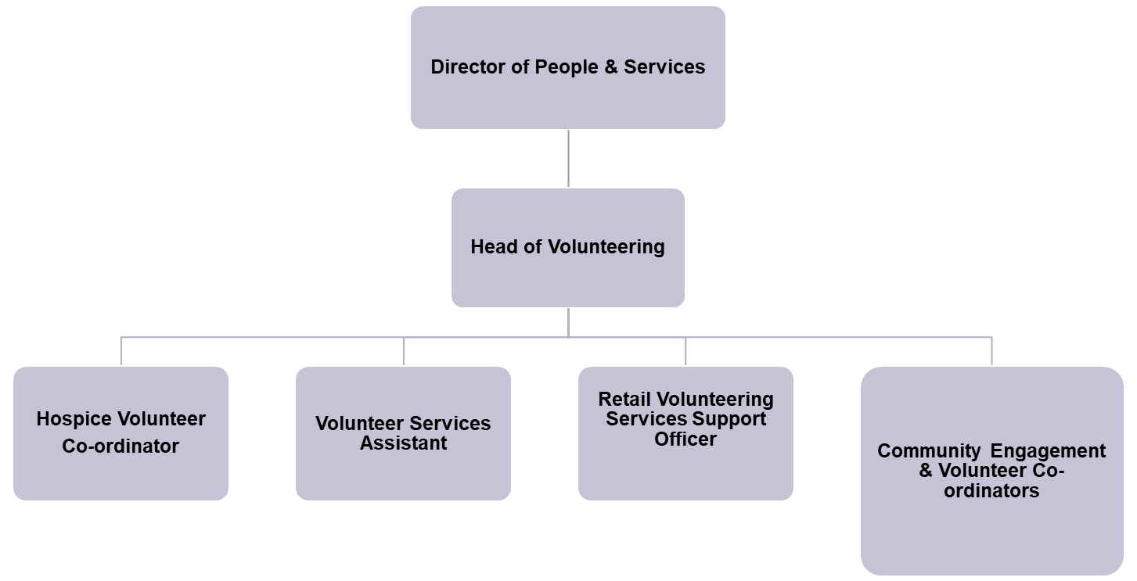

Contacts

Clinical teams
Internal network of volunteer ‘managers’
Patients and Families
Volunteers
Community representatives and groups
Volunteer networks / other third sector organisations
Service providers

Flexible working

Flexible working is required in this role (days/evenings & weekends). Travel is part of the role and therefore a car and clean driving licence are essential.

Special Note

This job description does not form a part of the contract of employment but indicates how that contract should be performed. The job description will be subject to amendment in the light of experience and in consultation with the post holder.

No Smoking Policy

Dorothy House operates a No Smoking Policy for all staff, volunteers and visitors in relation to promoting health. It applies to the Hospice premises and grounds at Winsley, all Dorothy House shops and when staff are on duty in patients’ homes.

Confidentiality

All of the work relating to patients, carers, donors, staff and volunteers and any other information gained are of a confidential nature and must not be communicated to other persons except in the course of duty.

Health and Safety at Work Act

It is the responsibility of all employees to ensure that the requirements of the Health and Safety at Work Act are complied with safe working practices are adhered to and that hazards are observed and reported to the appropriate office.

Safeguarding

Dorothy House is committed to promoting the wellbeing of all adults and children who use our services, ensuring that they live a life that is free from harm, abuse and neglect. We work in an open and transparent way and encourage staff, volunteers, patients and families to raise any safeguarding concerns. All staff should ensure that they are aware of their responsibilities and attend the mandatory training as required.

Person Specification
Criteria | Essential | Desirable
Health and Social care qualification and/or compensatory experience | x
Experience of community development/engagement | x
IT Literacy and experience of MS packages | x
Experience recruiting, supporting, engaging, motivating and managing volunteers | x
Experience working in community settings, facilitating training sessions and leading workshops | x
A proven track record of networking and building and managing effective interagency and collaborative relationships | x
Can demonstrate using own initiative and creativity to set up and develop a project, programme or area of work |  | x
Able to adapt to changing needs of the service | x
Ability to accurately record and manage data and report on outcomes to deadlines | x
Ability to manage competing demands and priorities and respond swiftly to ensure continuity of service provision | x
Ability to effectively use online meeting and training platforms including Teams & Zoom |  | x
Ability to empathise whilst being able to make professional judgements within an emotionally challenging environment | x
Understanding of safeguarding and confidentiality |  | x

